📚 MediaPipe Syllabus — From Scratch to Advanced



1️⃣ Introduction to MediaPipe
Goal: Understand what MediaPipe is and why it’s used.
- What is MediaPipe?
- History & Development (by Google)
- Key features and advantages
- Use cases in industry (AR, fitness tracking, face filters, hand gesture recognition)
- MediaPipe vs OpenCV vs Deep Learning frameworks
Practical:
- Install MediaPipe in Python (pip install mediapipe)
- Test installation with a sample program

2️⃣ MediaPipe Framework Overview
Goal: Learn the architecture.
- Graph-based architecture
- Components: Calculators, Graphs, and Solutions
- Cross-platform support (Python, C++, JavaScript, Android, iOS)
Practical:
- Create a simple MediaPipe pipeline to read webcam input

3️⃣ Working with Images & Videos
Goal: Understand input-output handling in MediaPipe.
- Reading images
- Working with webcam streams
- Processing video files
- Converting OpenCV frames for MediaPipe processing
Practical:
- Build a script that applies a basic face detection filter to an image and video

4️⃣ Face Detection
Goal: Detect faces in real-time.
- Face detection vs FaceMesh
- Bounding box detection
- Confidence threshold tuning
Practical:
- Real-time face detection using webcam
Assignment:
Detect faces in a video and mark them with rectangles.

5️⃣ FaceMesh
Goal: Detect facial landmarks.
- 468 facial landmark points
- Extracting coordinates of specific points (eyes, lips, nose)
- FaceMesh in static and live mode
- Applications (beauty filters, emotion detection)
Practical:
- Draw face mesh on webcam feed
- Highlight only eyes & lips landmarks

6️⃣ Hand Tracking
Goal: Detect and track hands.
- Detecting left & right hands
- 21 landmark points per hand
- Hand gesture classification (thumbs up, OK sign, etc.)
Practical:
- Real-time hand tracking system
- Simple gesture recognition program
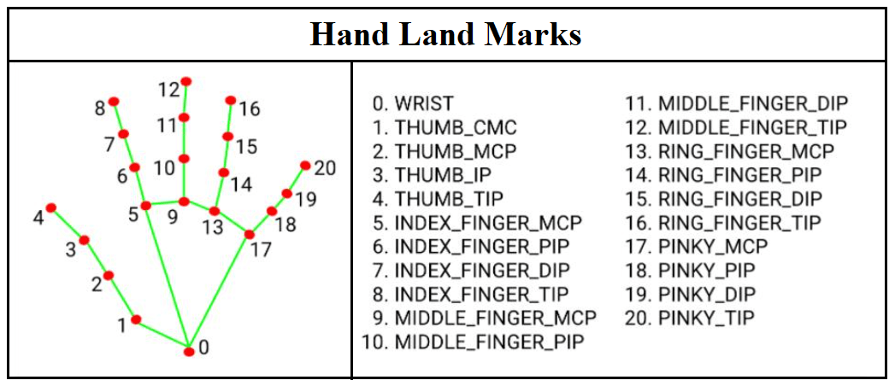
Assignment:
Control screen brightness with hand gestures.

7️⃣ Pose Detection
Goal: Detect body posture.
- Full-body 33 landmark points
- Detecting joints (elbows, knees, shoulders, hips)
- Measuring angles for fitness apps (e.g., squat counter)
Practical:
- Real-time pose detection
- Count push-ups or squats
Assignment:
Create a yoga pose correctness detector.
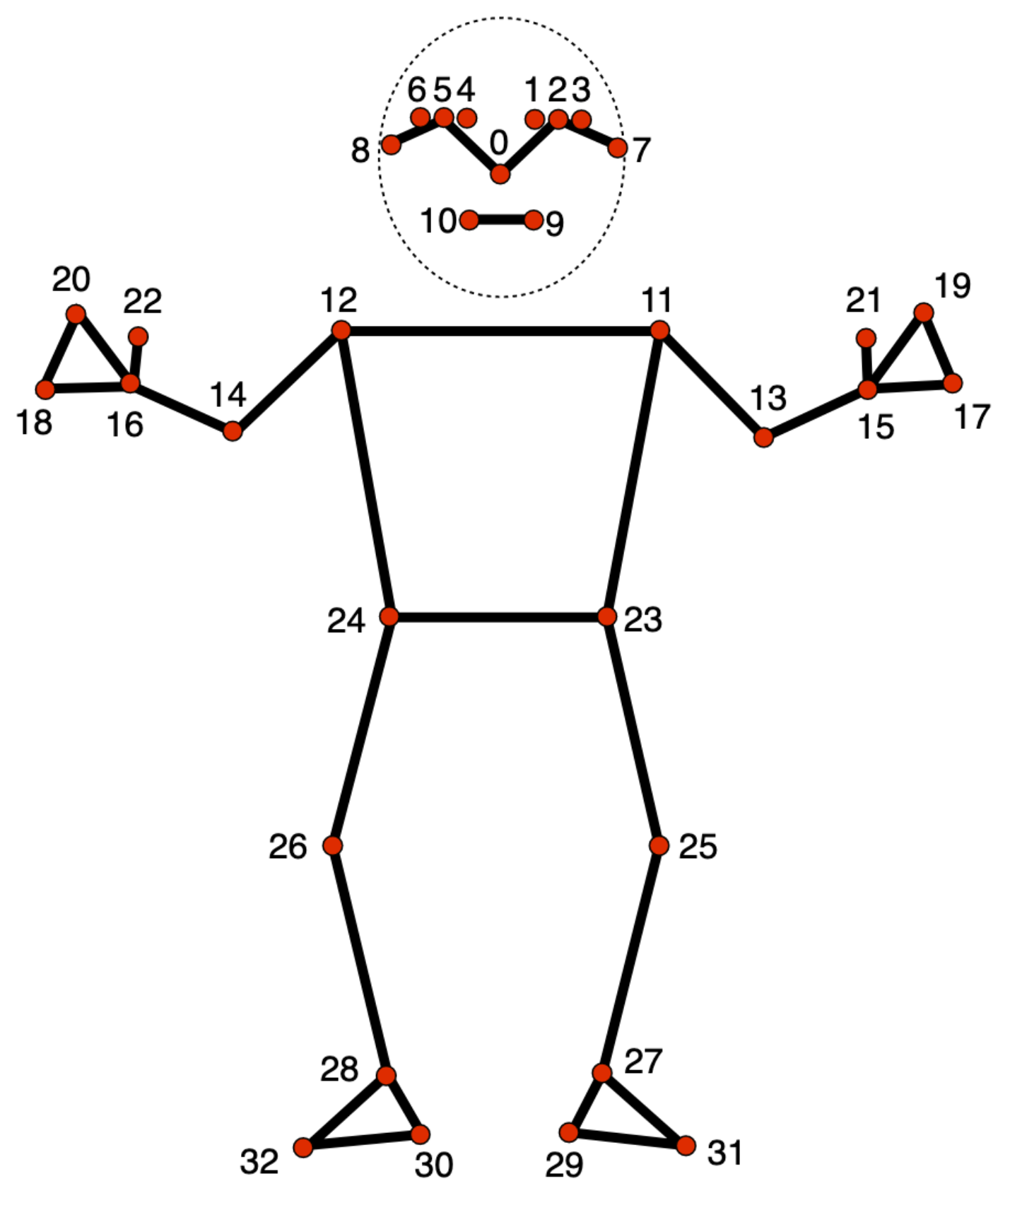

8️⃣ Holistic Model
Goal: Combine FaceMesh, Hand Tracking, and Pose Detection.
- Advantages of holistic tracking
- Synchronizing multiple models for real-time performance
Practical:
- Build a full holistic tracking pipeline for fitness tracking
Assignment:
Detect body pose + hand gestures together.
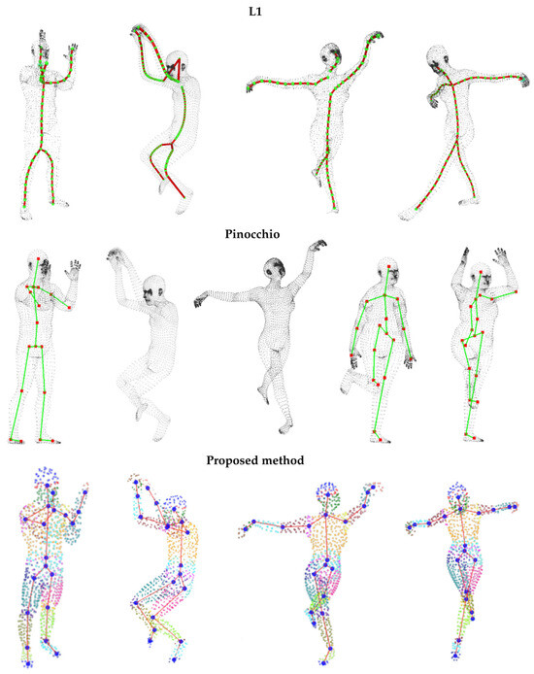

9️⃣ Objectron (3D Object Detection)
Goal: Detect objects in 3D.
- Introduction to Objectron
- Supported object types (shoe, chair, camera)
- Estimating 3D pose & bounding box
Practical:
- Detect and measure a shoe in real time

🔟 MediaPipe with Other Libraries
Goal: Integrate with OpenCV & deep learning models.
- OpenCV + MediaPipe for post-processing
- Sending MediaPipe outputs to TensorFlow/PyTorch models
- Using results for custom ML pipelines
Practical:
- Face detection with MediaPipe + classification with CNN

1️⃣1️⃣ MediaPipe in Web & Mobile
Goal: Deploy MediaPipe projects.
- MediaPipe in JavaScript (Web)
- MediaPipe in Android & iOS
- Performance optimization tips

1️⃣2️⃣ Advanced Projects
- Real-time Sign Language Detection (Hand tracking + Gesture classification)
- AI Fitness Trainer (Pose detection + Repetition counter)
- Face Filter App (FaceMesh + AR effects)
- 3D Object Measurement (Objectron)

1️⃣3️⃣ Assignments
- Hand gesture-based music player controller
- Eye-blink detection for drowsiness alert
- AI posture correction tool for office workers

1️⃣4️⃣ Capstone Project
Project:
"AI-based Interactive Fitness & Gesture Control System" — using MediaPipe Holistic + OpenCV to detect exercises, track repetitions, and control devices with gestures.

If you want, I can now integrate this MediaPipe syllabus into your Computer Vision roadmap so it fits seamlessly between OpenCV basics and advanced deep learning topics, making the full CV course flow perfectly.
Do you want me to merge it into that roadmap?

